NMAP TOOL – COMPREHENSIVE TECHNICAL DOCUMENTATION
A Network Mapping and Security Scanning Tool for Ethical Hacking & Penetration Testing
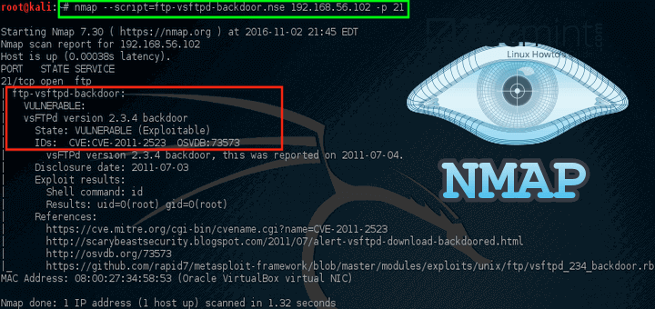
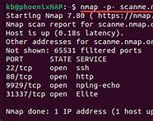
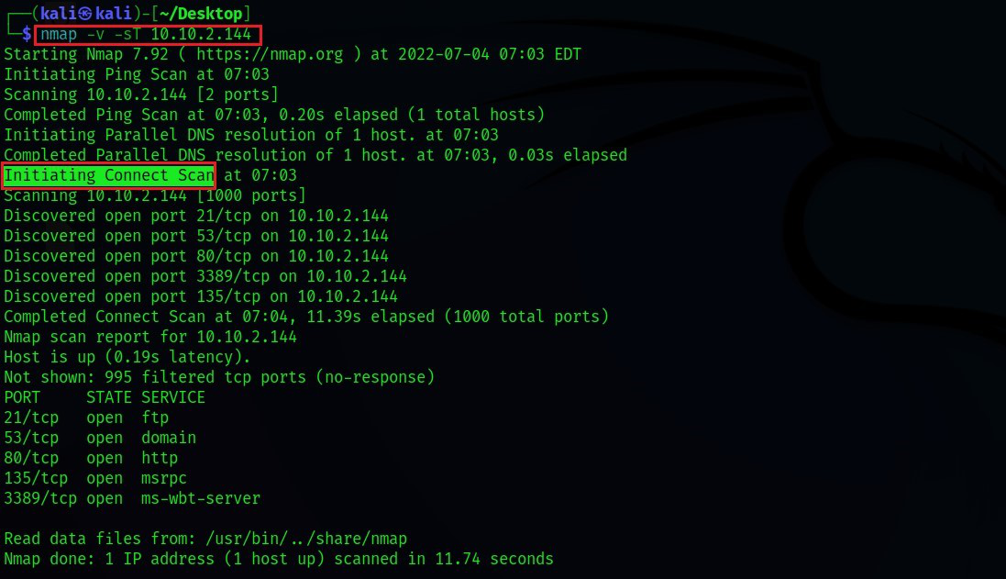
4

ABSTRACT
Network scanning is one of the most critical phases in penetration testing, bridging the gap between reconnaissance and exploitation. After identifying live hosts, security testers must determine which services, ports, and operating systems are running on those systems. This document presents a comprehensive technical study of Nmap (Network Mapper), the most widely used open-source network scanning tool in cyber security. The report explains the theoretical background, internal scanning mechanisms, command usage, scan types, practical case studies, advantages, limitations, and defensive considerations. The objective of this documentation is to provide an academic and practical understanding of Nmap suitable for cybersecurity coursework, lab records, interviews, and professional penetration testing engagements.

1. INTRODUCTION
In modern networked environments, systems expose multiple services through open ports. Each open port represents a potential entry point for attackers. Before exploiting vulnerabilities, it is essential to understand what services are running, how they are configured, and what versions are in use.
Nmap (Network Mapper) is a powerful and flexible tool designed to discover hosts, scan ports, identify services, detect operating systems, and enumerate vulnerabilities. It is considered the backbone of network scanning in ethical hacking.
Nmap is used by:
- Penetration testers
- Network administrators
- Security researchers
- Incident response teams
This document explores Nmap in depth from both academic and practical perspectives.

2. OBJECTIVE OF THE STUDY
The objectives of this documentation are:
- To understand the role of network scanning in penetration testing
- To study the working mechanism of Nmap
- To analyze different Nmap scan types and commands
- To demonstrate real-world usage through practical case studies
- To evaluate strengths, limitations, and security implications
- To provide exam-ready and submission-ready content

3. BACKGROUND: NETWORK SCANNING IN CYBER SECURITY
Network scanning is part of the Scanning & Enumeration phase in penetration testing. It focuses on identifying:
- Open ports
- Running services and versions
- Operating systems
- Network firewalls and filtering rules
Unlike reconnaissance tools that collect public information, scanning tools like Nmap interact directly with target systems, making this phase more detectable and sensitive.
Nmap supports multiple scanning techniques to adapt to different security environments.

4. OVERVIEW OF NMAP TOOL
Nmap is an open-source network scanner originally developed by Gordon Lyon (Fyodor). It is written in C/C++ and designed for performance, accuracy, and flexibility.
Nmap can perform:
- Host discovery
- Port scanning
- Service and version detection
- Operating system fingerprinting
- Script-based vulnerability enumeration
It is available on Linux, Windows, and macOS, and comes pre-installed in Kali Linux.

5. ARCHITECTURE AND WORKING MECHANISM
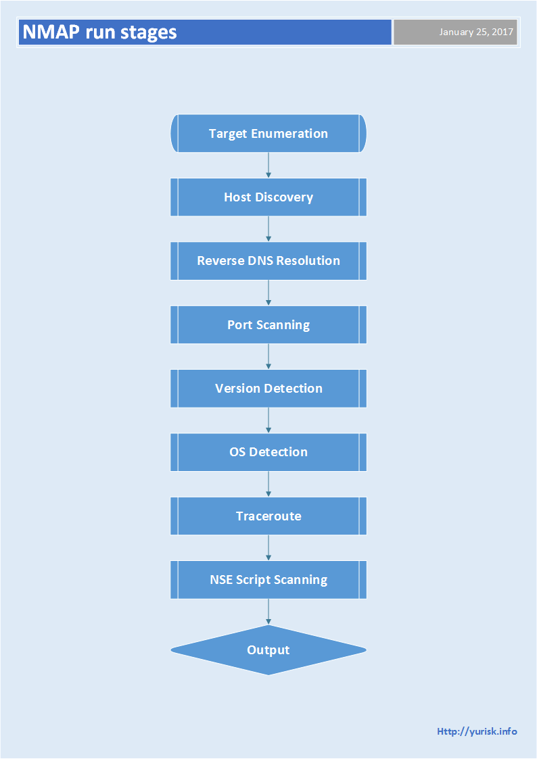
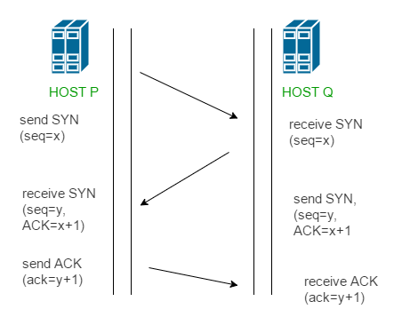
Nmap works by crafting and sending specially designed packets to target systems and analyzing their responses.
The general workflow is:
- Host Discovery – Identify live hosts
- Port Scanning – Determine open, closed, or filtered ports
- Service Detection – Identify applications and versions
- OS Detection – Fingerprint operating systems
- Scripting Engine (NSE) – Perform advanced enumeration
By analyzing packet responses, Nmap infers system behavior and security posture.

6. INSTALLATION AND ENVIRONMENT
Nmap is pre-installed in Kali Linux.
To verify installation:
nmap --version
Nmap may require root privileges for advanced scans such as SYN scanning and OS detection.

7. HOST DISCOVERY USING NMAP
7.1 Ping Scan
nmap -sn 192.168.1.0/24
Identifies live hosts without scanning ports.
7.2 Disable Ping (Assume Host is Up)
nmap -Pn 192.168.1.10
Used when ICMP is blocked.

8. PORT SCANNING TECHNIQUES
8.1 TCP SYN Scan (Stealth Scan)
nmap -sS 192.168.1.10
Fast and stealthy scan using half-open TCP connections.

8.2 TCP Connect Scan
nmap -sT 192.168.1.10
Completes full TCP handshake. Used when SYN scan is not permitted.

8.3 UDP Scan
nmap -sU 192.168.1.10
Identifies UDP services such as DNS, SNMP, and DHCP.

8.4 Scan All Ports
nmap -p- 192.168.1.10
Scans all 65,535 TCP ports.

9. SERVICE & VERSION DETECTION
nmap -sV 192.168.1.10
This scan identifies:
- Service names
- Software versions
- Application banners
Version detection is critical for vulnerability research.

10. OPERATING SYSTEM DETECTION
nmap -O 192.168.1.10
Nmap analyzes TCP/IP stack behavior to infer:
- Operating system family
- Kernel version
- Device type
Requires root privileges.

11. NMAP SCRIPTING ENGINE (NSE)
Nmap includes a powerful scripting engine that allows automation and vulnerability detection.
11.1 Default Scripts
nmap -sC 192.168.1.10
11.2 Vulnerability Scanning
nmap --script vuln 192.168.1.10
NSE scripts can detect:
- Weak authentication
- Misconfigurations
- Known vulnerabilities

12. PRACTICAL CASE STUDY
Scenario
A penetration tester scans a target server during an internal assessment.
Execution
nmap -sS -sV -O -p- 192.168.146.131
Findings
- Open ports: 22 (SSH), 80 (HTTP)
- Apache web server identified
- Linux operating system detected
Impact Analysis
The scan results guided the tester toward web exploitation and SSH brute-force testing.

13. ADVANTAGES OF NMAP
- Extremely versatile and powerful
- Supports multiple scan techniques
- Large community and documentation
- Integrated scripting engine
- Industry-standard tool

14. LIMITATIONS OF NMAP
- Detectable by IDS/IPS systems
- Requires expertise for advanced usage
- Slow for large networks without tuning
- Results depend on firewall behavior

15. NMAP VS OTHER SCANNING TOOLS
Tool | Strength | Best Use Case
Nmap | Versatility | Full network scanning
Masscan | Speed | Internet-scale scanning
Netcat | Manual testing | Service interaction
Zmap | High speed | Research scanning
Nmap balances power and precision.

16. SECURITY AND DEFENSIVE CONSIDERATIONS
Organizations can defend against Nmap scanning by:
- Deploying firewalls and IDS/IPS
- Monitoring unusual scan patterns
- Closing unused ports
- Regularly auditing exposed services

17. LEGAL AND ETHICAL CONSIDERATIONS
Nmap must only be used on systems where explicit authorization has been granted. Unauthorized scanning may be considered illegal reconnaissance or attempted intrusion.

18. CONCLUSION
Nmap is the cornerstone of network scanning in cyber security. Its ability to identify hosts, ports, services, and operating systems makes it indispensable for penetration testers and defenders alike. Mastering Nmap provides a strong foundation for understanding network security, attack surfaces, and defensive strategies.

19. REFERENCES
- Nmap Official Documentation
- Kali Linux Documentation
- OWASP Scanning & Enumeration Guide

